Order Of Service

Singing: Psalm 6—CW page 66

Reading: Psalm 126

Opening Hymn: CW 260

Reading: Romans 10:16-21

Request Hymn: CW Supplement 702

Reading: Matthew 21:18-22

Sermon Hymn: CW 363

Sermon Text: Luke 3:7-9

Generation Of Vipers

Prayer

The Apostles’ Creed, TLH page 12

Holy Communion

The Lord's Prayer

The Blessing

Closing Hymn: CW 327

* * * * * * * * * * *

Bible Study: Lambs: Wasp
Sheep: Proverbs 27:6-10

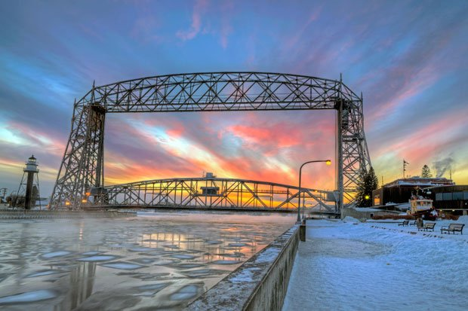

Winter Sunrise--Duluth, MN

Water
Of
Life

13 December 2020

W A T E R O F L I F E

Independent Christian Church—Conservative Lutheran Doctrine

Worship Service: 9:30 a.m. Bible Study: 10:45 a.m.

Larry Cooper, Pastor E-Mail address:
111 N. Ridge Road lcooper@wateroflife.cc
Coon Valley, WI 54623 Web Site:
www.wateroflife.cc

* * * * * * * * * * * * * * * * * * * * * * * * * * *

Sermon Text: Luke 3:7-9

Generation of Vipers

* * * * * * * * * * * * * * * * * * * * * * * * * * *

Luke 3:7 Then said he to the multitude that came forth to be baptized of him, O generation of vipers, who hath warned you to flee from the wrath to come?
:8 Bring forth therefore fruits worthy of repentance, and begin not to say within yourselves, We have Abraham to our father: for I say unto you, That God is able of these stones to raise up children unto Abraham.
9 And now also the axe is laid unto the root of the trees: every tree therefore which bringeth not forth good fruit is hewn down, and cast into the fire.

